Point Edward, Ontario
www.pointminor.ca
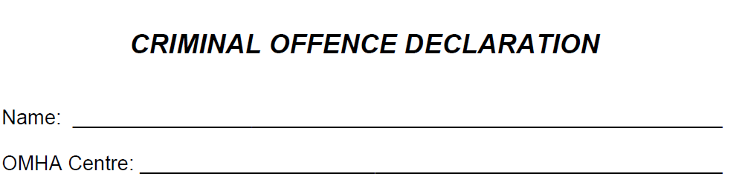

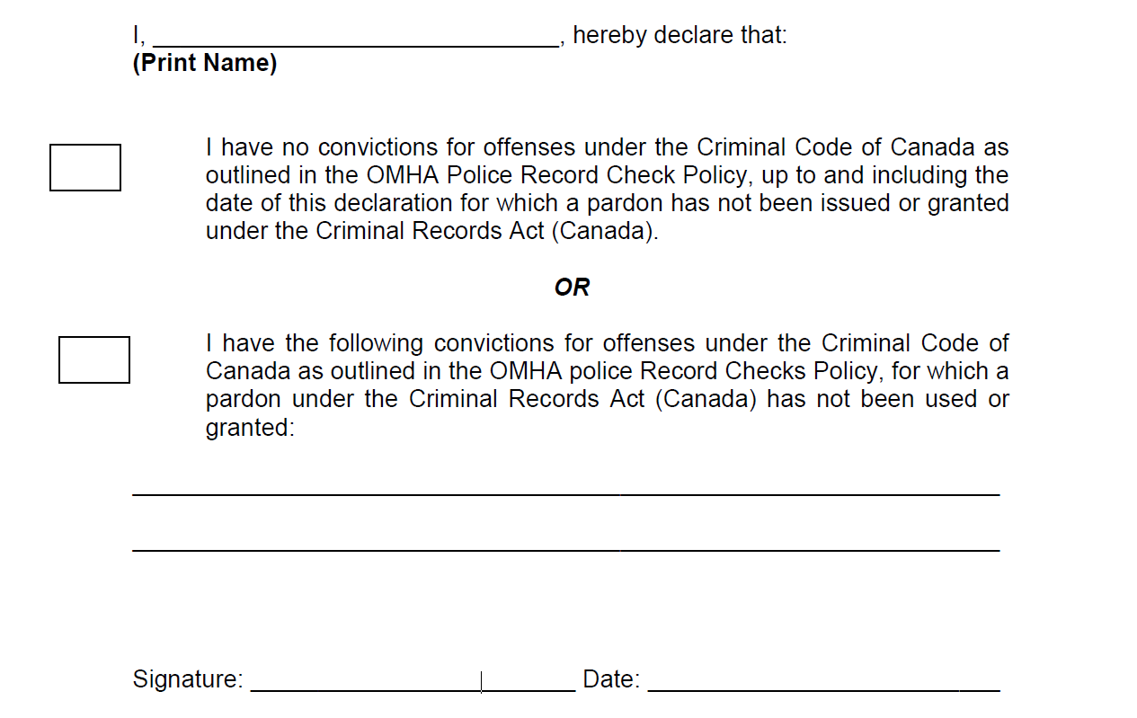

Please complete and submit in an envelope to PEMAA Hockey Conveners Liz Page, Scott Compagnion or Jane Sokol-Kennedy. Thank you.

