Hockey Is For Everyone

The NHL has launched a campaign to celebrate diversity, inclusion initiatives throughout the month of February

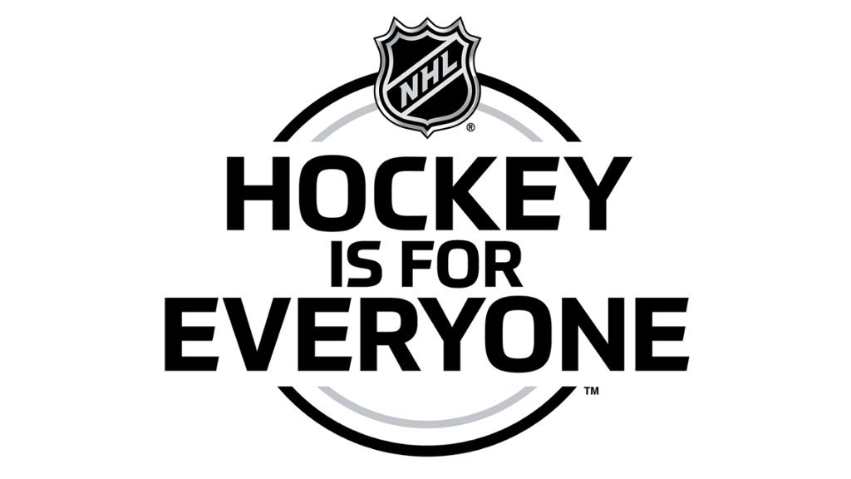

Every day throughout February, Hockey Is For Everyone activities will focus awareness on such areas as LGBTQ; ethnicity and gender equality; socio-economic status and those with disabilities. The campaign is conducted in partnership with the You Can Play Project -- a non-profit organization committed to supporting the LGBTQ community and fighting homophobia in sports. The campaign marks the first time the Players' Association, the League and its Clubs have collaborated to encourage teamwork, inclusiveness and diversity in hockey at all levels daily for an entire calendar month.
"Our Clubs, our players and our fans are committed to welcoming everyone to hockey," NHL Commissioner Gary Bettman said. "While the NHL family strives for diversity and inclusiveness all year long, February is Hockey Is For Everyone month, which will highlight, on a daily basis, the many ways our sport brings greater attention, heightened awareness and broader opportunities."

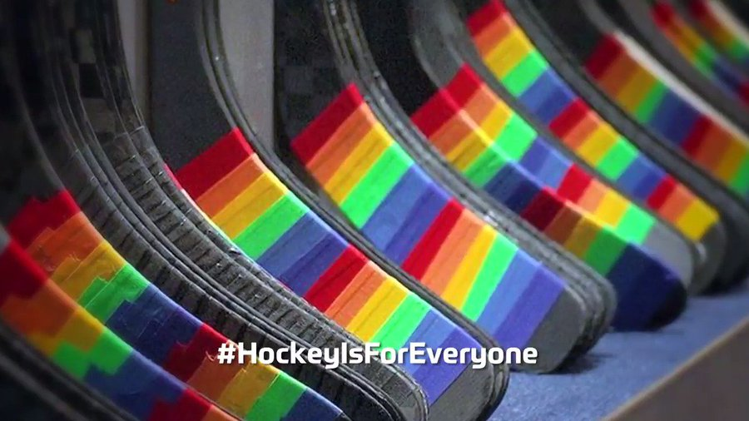

NHL
The Point Edward Minor Athletic Association is pleased to support this exciting initiative. We have purchased rainbow tape for each player to use as a visible reminder to fans, opposing teams, officials etc. Similar to our “Face Off for Mental Health” campaign, we are asking each player to have their stick taped with the rainbow tape for their February 3rd home game. As always, we appreciate everyone’s support in making this initiative successful, as always, your participation is voluntary.

