It’s OK to Talk … You’re a Blackhawk
Design a Mental Health Month Jersey
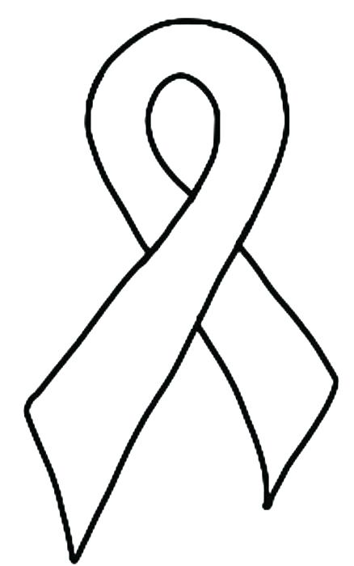
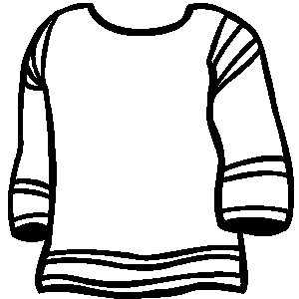
Name: _____________________
Division: ____________________

